M6932 Air Traffic Control
Tutorial Weather and ATM
Date Release: 26th Feb 2020
Date due 28th Feb 2020

Student Name: Tan Lai Chian Alan
Student ID: G1902299C

Tutorial Exercise 1:

In this exercise, you will find the METAR data from Singapore Changi Airport using NOAA web site.

Step 1: Go to website https://www.aviationweather.gov/metar

Step 2: Zoom into Singapore region

Step 3: Identify Singapore Changi Airport

Step 4: Click on the Station and observe the METAR data

Step 5: Decode and Report

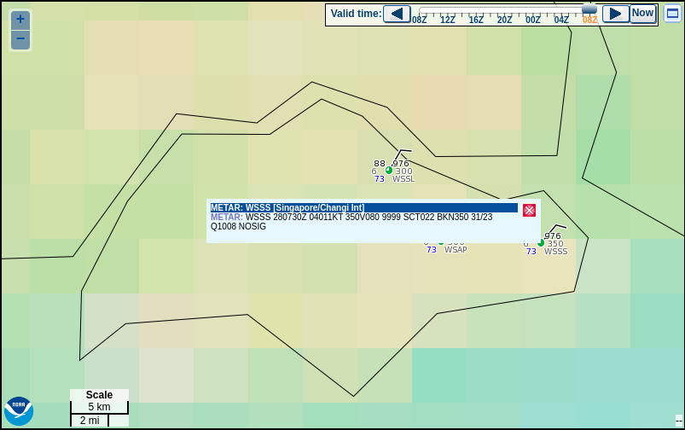

METAR for: WSSS (Singapore/Changi Int, –, SR)

Text: WSSS 280730Z 04011KT 350V080 9999 SCT022 BKN350 31/23 Q1008 NOSIG

Temperature: 31.0°C ( 88°F)

Dewpoint: 23.0°C (73°F) [RH = 63%]

Pressure (altimeter): 29.76 inches Hg (1008.0 mb)

Winds: from the NE (040 degrees) at 13 MPH (11 knots; 5.7 m/s)

Visibility: 6 or more sm (10+ km)

Ceiling: 35000 feet AGL

Clouds: scattered clouds at 2200 feet AGL, broken clouds at 35000 feet AGL

Tutorial Exercise 2:

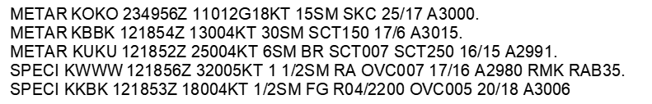

Which of the reporting stations have VFR weather?

1. All.

2. KOKO, KBBK, and KKBK.

3. KOKO, KBBK, and KUKU.

Refer to METAR above. The wind direction and velocity at KKBK is from

1. 180° magnetic at 4 knots.

2. 040° true at 18 knots.

3. 180° true at 4 knots.

Refer to METAR above. What are the wind conditions at KOKO?

1. 111° at 2 knots, gusts 18 knots.

2. 110° at 12 knots, gusts 18 knots.

3. Calm.

Refer to METAR above. The remarks section for KWWW has RAB35 listed. This entry means

1. the barometer has risen .35 in. Hg.

2. rain began at 1835Z.

3. blowing mist has reduced the visibility to 1-1/2 SM.

Refer to METAR above. What are the current conditions depicted for KWWW

1. Sky 7000 feet overcast, visibility 1-1/2SM, heavy rain.

2. Sky 700 feet overcast, visibility 11, occasionally 2SM, with rain.

3. Sky 700 feet overcast, visibility 1-1/2SM, rain.

Tutorial Exercise 3:

XyGrib is a Grib file reader and visualizes meteorological data providing an off-line capability to analyse weather forecasts. The XyGrib software is released as open source under the GPLv3 License.
You may watch this video (from 1:07 min onwards), to know how to use the software.
https://www.youtube.com/watch?v=VbO_DdVDd_s

It is intended to be used as a capable weather work station for anyone with a serious interest in examining weather.

XyGrib is currently available for all three desktop environments, Windows, Linux and Mac OS X operating systems.

XyGrib can display weather data from numerous. It can also:
- Visualize the weather by overlaying weather data on a map to create on-the-fly weather charts.
- Create an animation of the charts over the time steps of the forecast.
- Extract multiple weather values at any point and time in the forecast.
- Display a meteotable of data on a time axis for a given point.
- Display a meteograph of data on a time axis for a given point.
- Display surface and altitude data.
- Display an atmospheric sounding forecast on thermodynamic SkewT diagrams.
In this exercise, you will download an run XyGrib software. You will then locate (using coordinates of Singapore Changi Airport) and mark it as point of interest on XyGrib interface. You will then download Grib data for 7 days forecast for wind and temperature.
Use MetoTable Option by clicking on the point of interest (Changi Airport) to view and save the data in excel format.
You will then graph plot Temperature and Wind data for the next seven days using data from the excel file.

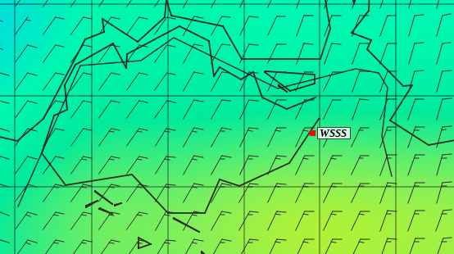

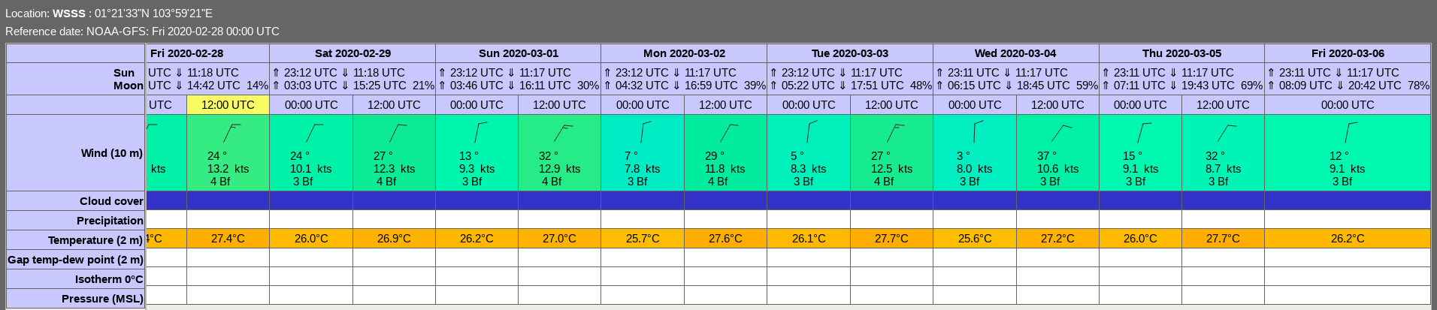
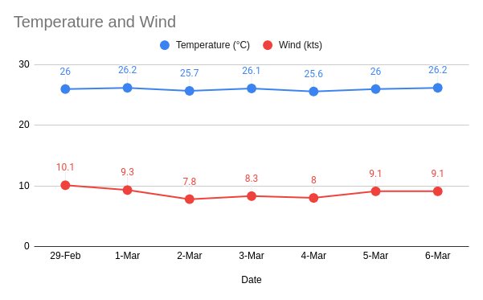

Tutorial Exercise 4:
Please refer following two manuals on course website
- ICAO Annex 3 Meteorological Service for International Air Navigation
- FAA Advisory Circular AC 00-45H Aviation Weather Services

Highlight and discuss the differences, if any, between FAA and ICAO method for METAR information/codes presentation and interpretation.

1) Visibility and Sky Condition

- In FAA, the metar abbreviation SKC is used to indicate clear sky

- In ICAO, CAVOK is used which implies a visibility of 10km and no cloud condition below 5000 ft or the highest minimum sector altitude and no cumulonimbus or towering cumulus at any level.

2) Altimeter setting

- FAA: Altimeter setting group codes the atmospheric pressure at elevation. This setting is then used by aircraft altimeters to determine the true altitude above a fixed plane of mean sea level (MSL). An altimeter setting of 29.92 in Hg (inches of Mercury) would be coded as A2992.

- ICAO: Altimeter setting group codes the atmospheric pressure at mean sea level. An altimeter setting of 1013 hPa (hector Pascal) would be coded at Q1013.

3) Wind speed

- FAA: kts

- ICAO: kmh/kts

